**Modern Education Society’s**

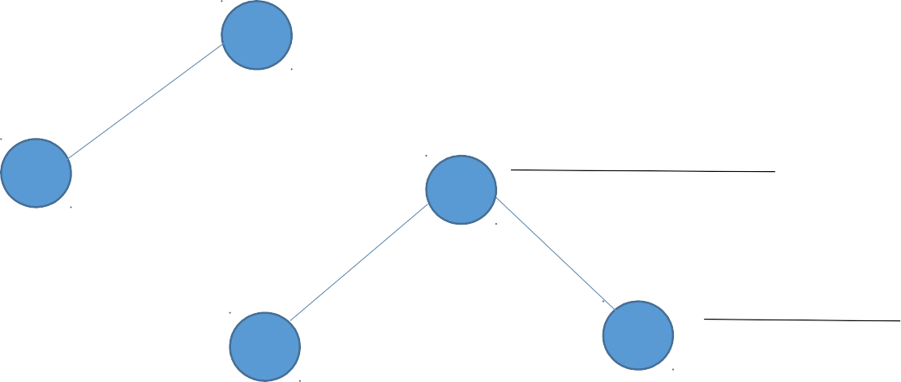

Example:

Level 0

In depth

A

B

Level 1

C

D

E

Level 2

Backtracks

F

# Wadia College of Engineering, Pune Department of Computer Engineering

|  |  |
| --- | --- |
| **NAME OF STUDENT:** | **CLASS:** |
| **SEMESTER/YEAR:** | **ROLL NO:** |
| **DATE OF PERFORMANCE:** | **DATE OF SUBMISSION:** |
| **EXAMINED BY:** | **EXPERIMENT NO: 01** |

**TITLE:** DEPTH FIRST SEARCH ALGORITHM AND BREADTH FIRST SEARCH ALGORITHM

**PROBLEM STATEMENT:** Implement Depth first search algorithm and Breadth First Search algorithm, use an undirected graph and develop a recursive algorithm for searching all the vertices of a graph or tree data structure.

# OBJECTIVES:

1. To understand Depth first search and Breadth first search algorithm and it’s importance.
2. To understand the implementation of recursive algorithm.

**PRE-REQUISITES:**

Depth First Search**:**

It is a recursive algorithm for traversing a tree or graph data structures.

It is called DFS because it starts from the root & follows each path to it’s greatest depth node before moving to the next path.

DFS uses a Stack data structure for its implementation.

Output is: A, B, D, C, E, F

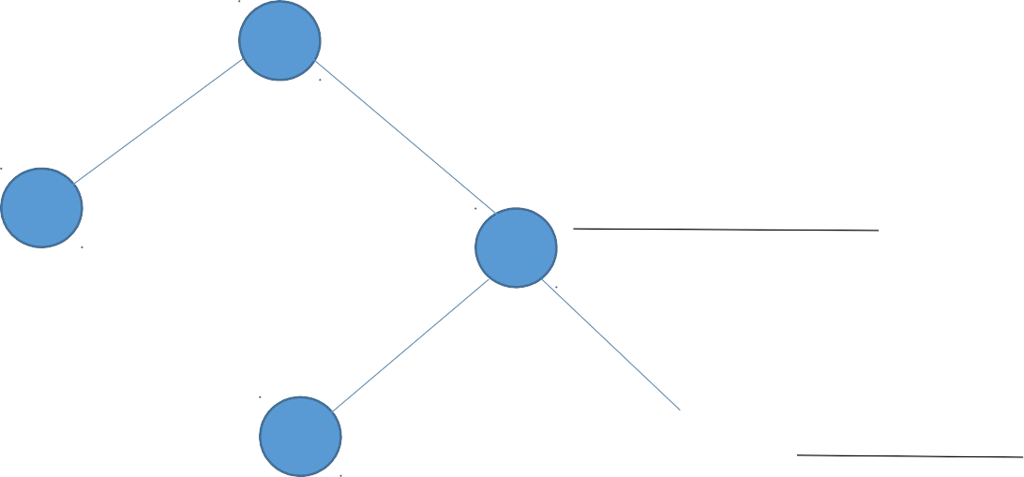

A

Level 0

In Breadth

B

Level 1

C

D

E

F

Level 2

# Breadth First Search (Level order Search)

Breadth First Search is a vertex based technique for finding a shortest path in graph. It uses a [Queue data structure](https://www.geeksforgeeks.org/queue-data-structure/) which follows first in first out.

In BFS, one vertex is selected at a time when it is visited and marked then its adjacent are visited and stored in the queue.

Output is: A, B, C, D, E, F

## Questions:

1] Difference between DFS & BFS.

2] What is time complexity of DFS algorithm?

3] What is time complexity of BFS algorithm?